***Notes to the Authors***

This is a template of a Requirements Document for your project with explanatory notes included.

**When using this template, the following steps are recommended:**

1. Replace all text enclosed in angle brackets (e.g., <Project Name>) with the correct values. These angle brackets appear either in the body of the document or in headers and footers.
2. To update the Table of Contents, right-click on it and select “Update field” and choose the option - “Update entire table”.
3. Turn off Tracking. Go to the Review tab; make sure Display for Review is set to “Final”.

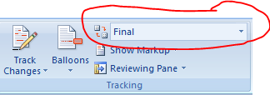

1. Before submission of this document, delete this instruction section “Notes to the Author”.



<Team Number>

Requirements Document

*NMMU Shuttle Service App*

Team Members:

|  |
| --- |
| 214251020 Siphato Kwrempe  214312674 Sithembile Ncube  214039846 Ndumiso Ndika |

31st March 2017

**TABLE OF CONTENTS**

1 PROJECT OVERVIEW 4

1.1 System Overview & Objective 4

1.2 System Assumptions 4

1.3 Deliverables Out of Scope 4

1.4 Stakeholders 4

1.4.1 Business Actors 4

1.4.2 Development Team 4

2 FUNCTIONAL REQUIREMENTS 5

2.1 Business Rules 5

2.2 Business Use Case Model 6

2.3 Use Case Glossary 7

2.4 Use Case Narratives (User Stories) 9

2.4.1 Package A: [insert package name] 9

2.4.2 Package B: [insert package name] 9

2.4.3 Package C: [insert package name] 9

2.4.4 Package D: [insert package name] 10

3 NON-FUNCTIONAL REQUIREMENTS 11

3.1 Interface Requirements 11

3.2 Performance Requirements 11

3.3 Security Requirements 11

3.4 Operational Requirements 11

4 DATA REQUIREMENTS 12

Appendix A – Summary of an Existing System 13

Appendix B – User Questions 14

# PROJECT OVERVIEW

## System Overview & Objective

Nelson Mandela Metropolitan University is a large public university with 5 campuses in Port Elizabeth alone. Most students live off campus with many making use of the free university shuttle system to travel to and from campus as well as between campuses for classes.

With a combination of increased enrollment to the university and changes to the academic calendar during 2016 and 2017, there has been a need seen for better management of the university shuttle system in order to ensure students travelling to and from campuses can all have access to the facilities when needed.

In order to alleviate the problems currently being faced by students such as shuttles being full well before departure time and the difficulty in planning shuttle routes for off-campus students, this system proposes to provide the following benefits to manage shuttle trips according to the number of registered students using the service, their destinations, and the students’ timetables:

* Students will be able to easily find shuttle routes for a given location upon request.
* Students will be able to receive real-time notifications of shuttle arrivals and changes to scheduling.
* Drivers and management will be able to see how many students are expected for a trip well before hand and make arrangements to respond to demands.
* The system will be able to track overall usage of the shuttle system and allow for better planning and allocation of resources within the shuttle management system.

## System Assumptions

* It is assumed that even though 3rd party transport management is used the university will be managing the shuttle service information system and will have access to all the contained data.
* It will also be assumed that drivers will have access to devices with network capabilities, however students may use the service online or offline with the most recent data available.

## Deliverables Out of Scope

The following will be considered out of the scope of the proposed system:

* Driver management: Driver details such as their salary and work hours will not be managed by the system. Only basic identification for the driver will be used for log in and tracking.
* Non-scheduled trips: Trips not scheduled as part of the shuttle service such as school society related trips will not be managed by this system.
* Vehicle management: Does not manage details of vehicle condition or physical history.

## Stakeholders

### Business Actors

| **Actor** | **Role** |
| --- | --- |
| Student | Student registration and maintaining details. Searching for vehicles and schedule details. Receiving notifications |
| Driver | Driver registration. Notifying users. |
| Administrator | Assigning vehicles. Assigning drivers. Updating details of vehicles. |

### Development Team

|  |
| --- |
| **Team Member** |
| Siphato Kwrempe |
| Sithembile Ncube |
| Ndumiso Ndika |

# FUNCTIONAL REQUIREMENTS

## Business Rules

|  |  |  |  |
| --- | --- | --- | --- |
| Rule ID | Rule | Source | Related Rule |
| BR001 | A student must be an NMMU student. |  |  |
| BR002 | A student must be going to or coming from an listed destination. |  |  |
| BR003 | A user must register before using the system. |  |  |
| BR004 | A student may have an arrival and departure time for each day of the work week. |  |  |
| BR005 | A schedule must be assigned to vehicle. |  |  |
| BR006 | A driver must be assigned to a vehicle by administrator. |  |  |
| BR007 | A vehicle must be assigned to a schedule by an administrator. |  |  |
| BR008 | A registered driver may not have had a vehicle assigned. |  |  |
| BR009 | Only administrators can assign vehicles and drivers. |  |  |
| BR010 | A non-user may view schedule. |  |  |
| BR011 | A vehicle must have a driver and schedule assigned. |  |  |
| BR012 | Multiple vehicles can be assigned to a schedule. |  |  |
| BR013 | A student can have up to five timetables. |  |  |
| BR014 | A student can only have one timetable for each day of the week. |  |  |

## Business Use Case Model

[Replace this text with the Business Use Case diagram – this must be drawn in Visio.]

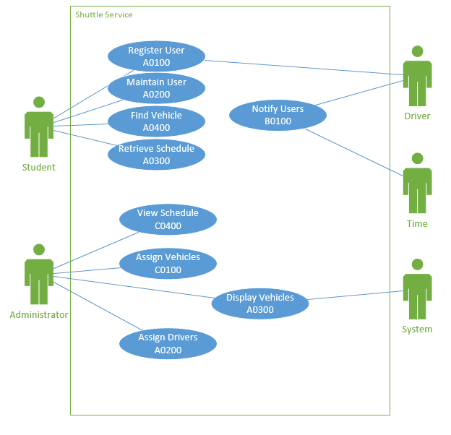

## Use Case Glossary

|  |  |  |
| --- | --- | --- |
| **Package Id: Package Name: Student** | | |
| **Use Case Id** | **Use Case Name** | **Actors** |
| A0100 | Register User | Student, Driver,  Administrator |
| A0200 | Maintain User | Student |
| **Queries/Reports** | | |
| A0300 | Retrieve Schedule | Student |
| A0400 | Find Vehicle | Student |

|  |  |  |
| --- | --- | --- |
| **Package Id: Package Name:Driver** | | |
| **Use Case Id** | **Use Case Name** | **Actors** |
| B0100 | Notify User | Driver |

|  |  |  |
| --- | --- | --- |
| **Package Id: Package Name: Administrator** | | |
| **Use Case Id** | **Use Case Name** | **Actors** |
| C0100 | Assign Vehicles | Administrator |
| C0200 | Assign Drivers | Administrator |
| **Queries/Reports** |  |  |
| C0300 | Display Vehicles | Administrator |
| C0400 | View Schedule | Administrator |

## Use Case Narratives (User Stories)

### Package A: [insert package name]

|  |  |  |
| --- | --- | --- |
| **Use Case ID** | **Use Case Name** | |
|  |  | |
| **Primary Business Actors** | | **Other participating Actors** |
|  | |  |
| **Description** |  | |
| **Pre-Conditions** |  | |
| **Triggers** |  | |
| **Post-Conditions** |  | |
| **Basic Flow of Events** |  | |

### Package B: [insert package name]

|  |  |  |
| --- | --- | --- |
| **Use Case ID** | **Use Case Name** | |
|  |  | |
| **Primary Business Actors** | | **Other participating Actors** |
|  | |  |
| **Description** |  | |
| **Pre-Conditions** |  | |
| **Triggers** |  | |
| **Post-Conditions** |  | |
| **Basic Flow of Events** |  | |

### Package C: [insert package name]

|  |  |  |
| --- | --- | --- |
| **Use Case ID** | **Use Case Name** | |
|  |  | |
| **Primary Business Actors** | | **Other participating Actors** |
|  | |  |
| **Description** |  | |
| **Pre-Conditions** |  | |
| **Triggers** |  | |
| **Post-Conditions** |  | |
| **Basic Flow of Events** |  | |

### Package D: [insert package name]

|  |  |  |
| --- | --- | --- |
| **Use Case ID** | **Use Case Name** | |
|  |  | |
| **Primary Business Actors** | | **Other participating Actors** |
|  | |  |
| **Description** |  | |
| **Pre-Conditions** |  | |
| **Triggers** |  | |
| **Post-Conditions** |  | |
| **Basic Flow of Events** |  | |

# NON-FUNCTIONAL REQUIREMENTS

## Interface Requirements

The NMMU Shuttle Service App will be a hybrid of a web application and Android application. The interfaces will follow the requirements stated below:

* Efficient: Displays only the necessary information to the user
* Mostly visual UI: Simple to use and using text when necessary
* Customized to students: Recent user history and queries will be saved in the app so upon opening, suggested data will be displayed to the student.\
* Safety: Students personal details are password protected and cannot be viewed by other users.

## Performance Requirements

To ensure the

* Updates on vehicle location and changes to scheduling must be transmitted immediately to online users
* If the app is being used offline, it must be able to quickly load saved schedules

## Security Requirements

Security features of the system should include

* Students, Drivers and Administrators accessing the system must each have a secure password.
* Students may only register using their provided university email address.

## Operational Requirements

The system should be accessible on most android devices.

# DATA REQUIREMENTS

|  |  |  |
| --- | --- | --- |
| **Entity** | **Example** | **Entity Attributes** |
| Driver |  | DriverID |
| Student | 214059205  [s214059205@nmmu.ac.za](mailto:s214059205@nmmu.ac.za)  South Campus  Korsten | studentNo  Email  Campus  Location |
| Schedule | 001  06:25  06:45  North End  South Campus | ScheduleID  DepTime  ArrivTime  DepLocation  ArrivLocation |
| Vehicle | JMG 516 EC  910324 5507 06 4  001  87 | VehicleID  DriverID  ScheduleID  Capacity |
| TimeTable | 21403698Monday  003  005 | StudentDay  scheduleStart  ScheduleEnd |
|  |  |  |
|  |  |  |
|  |  |  |
|  |  |  |
|  |  |  |

# Appendix A – Summary of an Existing System

# Appendix B – User Questions